**Assignment No.4**

**File Handling Commands in UNIX**

* **pwd**

**Use to know current working directory.**



* **cd**

**Use to change the current directory**

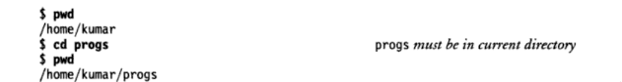

* **mkdir**

**Use to create directories.**







* **rmdir**

**Use to remove directories**





* **ls**

**Give a list of all filenames in the current directory**

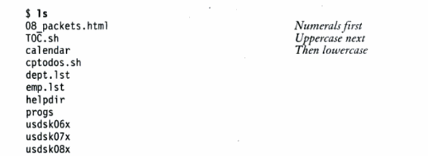

**Options with ls**

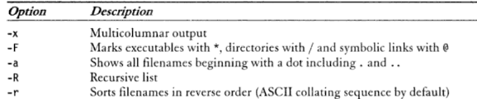

* **cat**

**Used to create a file and also used to open file content**

**Example:ls**

1. ***$cat file1 to create file1***
2. ***$cat file1 to view content of file1***

* **cp**

**Used to copying files**

**Example:**

***cp chap01 unit1***

***cp chap01 progs/unit1***

***cp chap01 chap02 chap03 progs multiple file copying into progs directory***

***cp chap* progs copies all file beginning with chap***

***catrm***

* **rm**

**Used to delete one or more files.**

**Example:**

***rm chap01***

***rm chap01 chap02 chap03 multiple file deletion***

***rmprogs/chap01 progs/chap02***

***cdwc***

***rm * remove all files***

* **mv**

**it renames or moves files.**

**Example:**

***mv chap01 man01***

***mv chap01 chap02 chap03 progs multiple files moved to progs directory***

***mvprogsnewprogs rename a directory***

* **file**

**Used to determine the type of file**

**Syntax:**

***$file [filename]***

**Example:**



* **wc**

**Counts lines, words and characters**

**Example:**

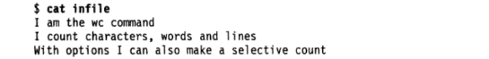



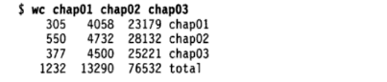

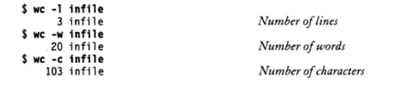

* **cmp**

**Used to compare to files and gives position of first mismatch as a result**

**Example:**



* **comm**

**Find common between two files.**

**Example:**

***$comm file1 file2***

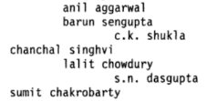

* **diff**

**Used to display file differences and also tells which lines in one file have to be changed to make the two files identical**

**Example:**

